**Project Report**

**Smart Agriculture system based on IoT**

Name : Anudeep Kaja

Category : IoT

Mail Id : anudeepkaja@gmail.com

**Contents**

1. Introduction
   1. Overview…………………………………………………..3
2. Literature Survey

2.1Proposed Solution……………………………………………3

1. Project Description………………………………………………4
2. Project Scope

4.1 Project Summary…………………………………………….4

4.2 Project Requirements…………………………………………4

4.3 Software Requirements……………………………………….4

4.4 Project Deliverables…………………………………………..4

1. Node-Red Flow…………………………………………………..5
2. Watson IOT Sensor………………………………………………6
3. Node-Red UI Dashboard…………………………………………6
4. Advantages and Disadvantages……………………………………7

9.1 Advantages

9.2 Disadvantages

1. Applications………………………………………………………7
2. Conclusion………………………………………………………7
3. Future Scope………………………………………………………8

12 . Node-RED Flow (json)………………………………………….8

13. Python Code……………………………………………………..11

**1. Introduction**

**1.1 Overview**

* Agriculture is a major source of income for the largest population in India and is a major contributor to the Indian economy.
* In the past decade it is observed that there is not much crop development in the agriculture sector.
* Food prices are continuously increasing because crop rate declined.
* There are number of factor which handles this, it may be due to water waste, low soil fertility, Fertilizer abuse, climate change or diseases etc.
* It is very essential to make effective intervention in agriculture and the solution is IOT in integration with wireless sensor network.
* The Internet of things (IOT) is a method of connecting everything to the internet - it is connecting objects or things (such as car, home, electronic devices, etc.) which are previously not connected with each other.
* The main purpose of IOT is to ensure the delivery of right information to right people at the right time.
* In agriculture irrigation is the important factor as the monsoon rain falls are unpredictable and uncertain.

**2. Literature Survey**

**2.1Proposed Solution**

IoT is based on SMART AGRICULTURE SYSTEM is regarded as the IoT gadget focusing on Live Monitoring of Environmental data in terms of Temperature, Moisture and Humidity of atmosphere and the plant/crop. The system provides the concept of “Plug and Sense” in which farmers can directly implement smart farming by such as putting the System on the field and getting Live Data feeds on various electronic devices using Web Application. Moreover, the data generated via sensors can be easily shared and viewed by agriculture consultants anywhere remotely via Cloud Computing technology integration. The system allows manually to turn the pumping motor ON and OFF on sensing the moisture content of the soil.

**3. Project Description**

* Smart Agriculture System based on IoT can monitor soil moisture and climatic conditions to grow and yield a good crop.
* The farmer can also get the realtime weather forecasting data by using external platforms like Open Weather API.
* Farmer is provided a mobile app using which he can monitor the temperature,humidity and soil moisture parameters along with weather forecasting details.
* Based on all the parameters he can water his crop by controlling the motors using the mobile application.
* Even if the farmer is not present near his crop he can water his crop by controlling the motors using the mobile application from anywhere.
* Here we are using the Online IoT simulator for getting the Temperature,Humidity and Soil Moisture values.

**4. Project Scope**

**4.1 Project Summary**

* Smart Agriculture System based on IoT can monitor soil moisture and climatic conditions to grow and yield a good crop.
* A Farmer is provided a mobile app using which he can monitor the temperature,humidity and soil moisture parameters along with weather forecasting details.
* Based on all the parameters he can water his crop by controlling the motors using the mobile application
  1. **Project Requirements**
* IOT Application Development
* IOT Cloud Platform

**4.3 Software Requirements**

* GIT tool and Nodered
* Python IDE

**4.4 Project Deliverables**

* Explore IBM Cloud Platform
* Connect The IOT Simulator To Watson IOT Platform
* Configure The Nodered To Get The Data From IBM IOT Platform And Open Weather API
* Building A Web App
* Configure Device To Receive The Data From The Web Application And  Control Motors

**5.Node-Red Flow**

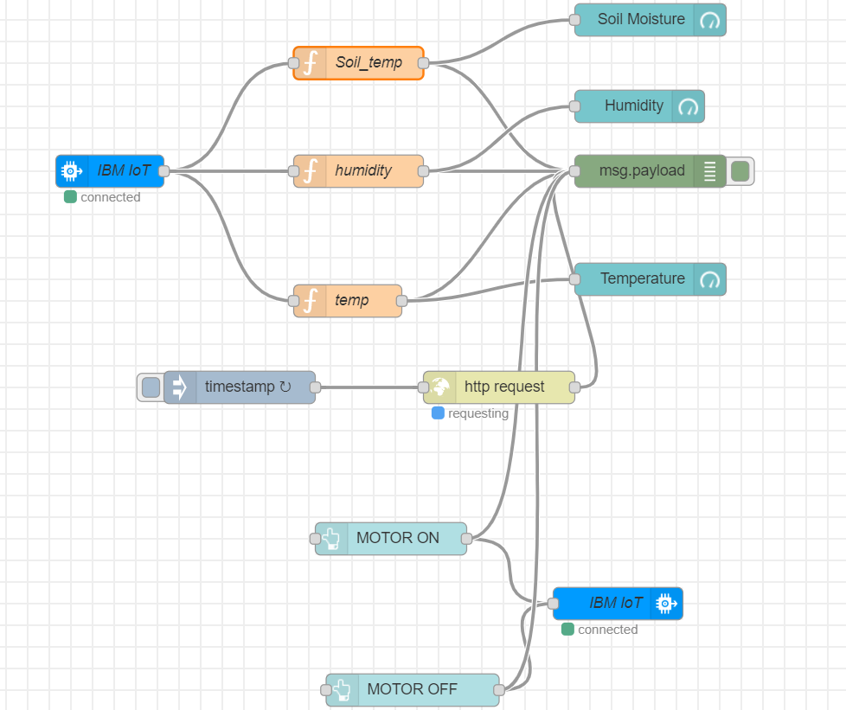

**6. Watson IOT Sensor**

|  |  |  |
| --- | --- | --- |
|  |  |  |

**7. Node-Red UI Dashboard**

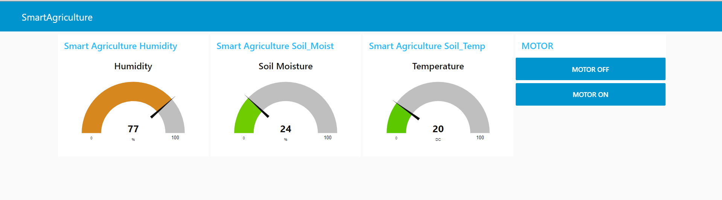

**8. Advantages and Disadvantages**

**8.1 Advantages**

* Small sized customer support team is enough as only a low volume of queries are redirected.
* Cost efficient.
* Only a small amount of queries need representatives, hence the customer is also satisfied with quick and easy solution.
  1. **Disadvantages**
* The IBM Watson Discovery service returns wrong results if not properly configured.
* Same answers might be given for different queries.

**9. Applications**

* Using the IoT concept in the agriculture field will help farmers not only reduce waste but also increase in yield production varying from the quantity of fertilizer utilized to the quality of the production achieved.
* These days IoT has also been implemented in these following practices.
  1. Crop Monitoring: Using IoT technique we can monitor the quality of crop.
  2. Precision Farming: Precision farming is a farming practice that is more accurate and controlled. It deals with production of crop along with raising livestock.
  3. Livestock Monitoring: With the help of sensor, health of the livestock can be monitored which will directly help in the yield production of good produced from them.
  4. Agricultural drones: It is a good example for farming and in order to improve the various agricultural practices.

**10.Conclusion**

By following the above-mentioned steps, we create a basic chatbot which can help us to answer the basic questions of the customer or user related to location of the office, working hours and the information about the product. We have successfully created the intelligent help desk smart chatbot using IBM Watson Assistant, IBM Cloud Function, IBM Watson Discovery and Node-Red.

**11. Future Scope**

In the future, the bot can be improvised with live UI. Also, features like similar information, helpline contacts, Watson text to audio, extended user requests, a database to store and display recent chats, etc.

**12. Node-RED Flow (json)**

[{"id":"445a7c69.eed4e4","type":"tab","label":"Flow 1","disabled":false,"info":""},{"id":"da188ab1.bd4328","type":"tab","label":"Flow 2","disabled":false,"info":""},{"id":"8fb72b2a.281338","type":"tab","label":"iot","disabled":false,"info":""},{"id":"aa338777.b339c8","type":"tab","label":"Flow 4","disabled":false,"info":""},{"id":"6aeb4ff8.78fb","type":"ibmiot","z":"","name":"","keepalive":"60","serverName":"","cleansession":true,"appId":"","shared":false},{"id":"76e7536.59766ac","type":"ui_base","theme":{"name":"theme-light","lightTheme":{"default":"#0094CE","baseColor":"#0094CE","baseFont":"-apple-system,BlinkMacSystemFont,Segoe UI,Roboto,Oxygen-Sans,Ubuntu,Cantarell,Helvetica Neue,sans-serif","edited":true,"reset":false},"darkTheme":{"default":"#097479","baseColor":"#097479","baseFont":"-apple-system,BlinkMacSystemFont,Segoe UI,Roboto,Oxygen-Sans,Ubuntu,Cantarell,Helvetica Neue,sans-serif","edited":false},"customTheme":{"name":"Untitled Theme 1","default":"#4B7930","baseColor":"#4B7930","baseFont":"-apple-system,BlinkMacSystemFont,Segoe UI,Roboto,Oxygen-Sans,Ubuntu,Cantarell,Helvetica Neue,sans-serif"},"themeState":{"base-color":{"default":"#0094CE","value":"#0094CE","edited":false},"page-titlebar-backgroundColor":{"value":"#0094CE","edited":false},"page-backgroundColor":{"value":"#fafafa","edited":false},"page-sidebar-backgroundColor":{"value":"#ffffff","edited":false},"group-textColor":{"value":"#1bbfff","edited":false},"group-borderColor":{"value":"#ffffff","edited":false},"group-backgroundColor":{"value":"#ffffff","edited":false},"widget-textColor":{"value":"#111111","edited":false},"widget-backgroundColor":{"value":"#0094ce","edited":false},"widget-borderColor":{"value":"#ffffff","edited":false},"base-font":{"value":"-apple-system,BlinkMacSystemFont,Segoe UI,Roboto,Oxygen-Sans,Ubuntu,Cantarell,Helvetica Neue,sans-serif"}},"angularTheme":{"primary":"indigo","accents":"blue","warn":"red","background":"grey"}},"site":{"name":"Node-RED Dashboard","hideToolbar":"false","allowSwipe":"false","lockMenu":"false","allowTempTheme":"true","dateFormat":"DD/MM/YYYY","sizes":{"sx":48,"sy":48,"gx":6,"gy":6,"cx":6,"cy":6,"px":0,"py":0}}},{"id":"596d0a9d.bd49a4","type":"ui_tab","z":"","name":"SmartAgriculture","icon":"dashboard","disabled":false,"hidden":false},{"id":"17ded8fb.912b97","type":"ui_group","z":"","name":"Smart Agriculture Soil_Temperature","tab":"596d0a9d.bd49a4","order":1,"disp":true,"width":"6","collapse":false},{"id":"79cbcd10.30e694","type":"ui_group","z":"","name":"Smart Agriculture Soil_Temperature","tab":"596d0a9d.bd49a4","order":2,"disp":true,"width":"6","collapse":false},{"id":"e14da21b.e13e9","type":"ui_group","z":"","name":"Smart Agriculture Humidity","tab":"596d0a9d.bd49a4","order":3,"disp":true,"width":"6","collapse":false},{"id":"f75fd605.f05268","type":"ui_group","z":"","name":"Smart Agriculture Soil_Temperature","tab":"596d0a9d.bd49a4","order":4,"disp":true,"width":"6","collapse":false},{"id":"1b4e7ef9.363941","type":"ui_group","z":"","name":"Smart Agriculture Soil_Moist","tab":"596d0a9d.bd49a4","order":5,"disp":true,"width":"6","collapse":false},{"id":"9f6fe93a.459ac8","type":"ui_group","z":"","name":"DefaultSmart Agriculture Soil_Temp","tab":"596d0a9d.bd49a4","order":6,"disp":true,"width":"6","collapse":false},{"id":"f23e8cf1.b8246","type":"ui_group","z":"","name":"Smart Agriculture Soil_Temp","tab":"596d0a9d.bd49a4","order":7,"disp":true,"width":"6","collapse":false},{"id":"1917c723.1d6319","type":"ui_group","z":"","name":"MOTOR","tab":"596d0a9d.bd49a4","order":8,"disp":true,"width":"6","collapse":false},{"id":"25ea93d2.09c94c","type":"inject","z":"445a7c69.eed4e4","name":"send data","topic":"","payload":"","payloadType":"date","repeat":"","crontab":"","once":true,"onceDelay":"1","x":60,"y":140,"wires":[["12f4b043.f2666"]]},{"id":"12f4b043.f2666","type":"function","z":"445a7c69.eed4e4","name":"Device Payload","func":"// Array of pseudo random temperatures\nvar temp1 = [15,17,18.5,20,21.5,23,24,22.2,19,32];\n\n// Array of pseudo random relative humidities\nvar humidity1 = [50,55,61,68,65,60,53,49,45,47];\n\n// Counter to select from array.\nvar counter1 = context.get('counter1')||0;\ncounter1 = counter1+1;\nif(counter1 > 9) counter1 = 0;\ncontext.set('counter1',counter1);\n\n// Create MQTT message in JSON\nmsg = {\n payload: JSON.stringify(\n {\n d:{\n \"temperature\" : temp1[counter1],\n \"humidity\" : humidity1[counter1] }\n }\n )\n};\nreturn msg;","outputs":1,"noerr":0,"x":220,"y":140,"wires":[["4c42704f.cb054","88b54edc.b7ceb"]]},{"id":"4c42704f.cb054","type":"ibmiot out","z":"445a7c69.eed4e4","authentication":"quickstart","apiKey":"","outputType":"evt","deviceId":"farming1234","deviceType":"1.0.6","eventCommandType":"temp","format":"json","data":"number","qos":0,"name":"Temperature Device","service":"quickstart","x":520,"y":140,"wires":[]},{"id":"88b54edc.b7ceb","type":"debug","z":"445a7c69.eed4e4","name":"","active":true,"tosidebar":true,"console":false,"tostatus":false,"complete":"Debug output","targetType":"msg","x":500,"y":80,"wires":[]},{"id":"f1c8b960.d534d8","type":"ibmiot in","z":"da188ab1.bd4328","authentication":"apiKey","apiKey":"","inputType":"evt","logicalInterface":"","ruleId":"","deviceId":"farming1234","applicationId":"","deviceType":"+Farming","eventType":"+","commandType":"","format":"json","name":"Application","service":"registered","allDevices":false,"allApplications":"","allDeviceTypes":false,"allLogicalInterfaces":"","allEvents":true,"allCommands":"","allFormats":"","qos":0,"x":90,"y":120,"wires":[["f6a935d7.d67848"]]},{"id":"f6a935d7.d67848","type":"function","z":"da188ab1.bd4328","name":"Extract Temperature","func":"\nreturn {payload:msg.payload.d.temperature};","outputs":1,"noerr":0,"x":280,"y":120,"wires":[["4291632.df5259c"]]},{"id":"a9f9bc43.0393c","type":"debug","z":"da188ab1.bd4328","name":"","active":true,"tosidebar":true,"console":false,"tostatus":false,"complete":"false","x":870,"y":120,"wires":[]},{"id":"4291632.df5259c","type":"switch","z":"da188ab1.bd4328","name":"classify","property":"payload","propertyType":"msg","rules":[{"t":"eq","v":"30","vt":"str"}],"checkall":"true","repair":false,"outputs":1,"x":500,"y":120,"wires":[["7b4e5abc.d2e834","ff7af09a.25864"]]},{"id":"7b4e5abc.d2e834","type":"template","z":"da188ab1.bd4328","name":"danger","field":"payload","fieldType":"msg","format":"handlebars","syntax":"mustache","template":"\nTemperature ({{payload}}) critical ","output":"str","x":700,"y":60,"wires":[["a9f9bc43.0393c"]]},{"id":"ff7af09a.25864","type":"template","z":"da188ab1.bd4328","name":"safe","field":"payload","fieldType":"msg","format":"handlebars","syntax":"mustache","template":"Temperature ({{payload}}) within safe limits","output":"str","x":710,"y":160,"wires":[["a9f9bc43.0393c"]]},{"id":"db59ceca.2d418","type":"ibmiot in","z":"8fb72b2a.281338","authentication":"apiKey","apiKey":"6aeb4ff8.78fb","inputType":"evt","logicalInterface":"","ruleId":"","deviceId":"12012000","applicationId":"","deviceType":"nodemcu","eventType":"+","commandType":"","format":"json","name":"IBM IoT","service":"registered","allDevices":"","allApplications":"","allDeviceTypes":"","allLogicalInterfaces":"","allEvents":true,"allCommands":"","allFormats":"","qos":0,"x":236,"y":220,"wires":[["7006cf5f.35a63","bcf99d93.8ed6f","70ac65bd.bededc"]]},{"id":"a0630263.dac86","type":"debug","z":"8fb72b2a.281338","name":"","active":true,"tosidebar":true,"console":false,"tostatus":false,"complete":"payload","targetType":"msg","x":736,"y":220,"wires":[]},{"id":"7006cf5f.35a63","type":"function","z":"8fb72b2a.281338","name":"temp","func":"msg.payload=msg.payload.d.temperature;\nreturn msg","outputs":1,"noerr":0,"x":456,"y":340,"wires":[["a0630263.dac86","cceeaf95.634f7"]]},{"id":"cceeaf95.634f7","type":"ui_gauge","z":"8fb72b2a.281338","name":"","group":"f23e8cf1.b8246","order":0,"width":0,"height":0,"gtype":"gage","title":"Temperature","label":"DC","format":"{{value}}","min":0,"max":"100","colors":["#00b500","#e6e600","#ca3838"],"seg1":"","seg2":"","x":736,"y":320,"wires":[]},{"id":"70ac65bd.bededc","type":"function","z":"8fb72b2a.281338","name":"humidity","func":"msg.payload=msg.payload.d.humidity;\nreturn msg;","outputs":1,"noerr":0,"x":466,"y":220,"wires":[["a0630263.dac86","b457691b.30aa58"]]},{"id":"bcf99d93.8ed6f","type":"function","z":"8fb72b2a.281338","name":"Soil_temp","func":"msg.payload=msg.payload.d.objectTemp;\nreturn msg;","outputs":1,"noerr":0,"x":466,"y":120,"wires":[["a0630263.dac86","378bc372.649bac"]]},{"id":"b457691b.30aa58","type":"ui_gauge","z":"8fb72b2a.281338","name":"","group":"e14da21b.e13e9","order":1,"width":0,"height":0,"gtype":"gage","title":"Humidity","label":"%","format":"{{value}}","min":0,"max":"100","colors":["#00b500","#e6e600","#ca3838"],"seg1":"","seg2":"","x":726,"y":160,"wires":[]},{"id":"378bc372.649bac","type":"ui_gauge","z":"8fb72b2a.281338","name":"","group":"1b4e7ef9.363941","order":2,"width":0,"height":0,"gtype":"gage","title":"Soil Moisture","label":"%","format":"{{value}}","min":0,"max":"100","colors":["#00b500","#e6e600","#ca3838"],"seg1":"","seg2":"","x":736,"y":80,"wires":[]},{"id":"7ed48bd2.4eed34","type":"ibmiot in","z":"aa338777.b339c8","authentication":"apiKey","apiKey":"6aeb4ff8.78fb","inputType":"evt","logicalInterface":"","ruleId":"","deviceId":"12012000","applicationId":"","deviceType":"+nodemcu","eventType":"+","commandType":"","format":"json","name":"IBM IoT","service":"registered","allDevices":"","allApplications":"","allDeviceTypes":"","allLogicalInterfaces":"","allEvents":true,"allCommands":"","allFormats":"","qos":0,"x":130,"y":220,"wires":[["d61ca2ec.569e3"]]},{"id":"d61ca2ec.569e3","type":"debug","z":"aa338777.b339c8","name":"","active":true,"tosidebar":true,"console":false,"tostatus":false,"complete":"false","x":450,"y":220,"wires":[]},{"id":"eb9dd4f4.6254e8","type":"http request","z":"8fb72b2a.281338","name":"","method":"GET","ret":"obj","paytoqs":false,"url":"api.openweathermap.org/data/2.5/weather?q=Hyderabad,IN&appid=c03c513f8eb8c6ea403851d0a3e3e7c0","tls":"","persist":false,"proxy":"","authType":"","x":596,"y":420,"wires":[["a0630263.dac86"]]},{"id":"e03d32ab.aa523","type":"inject","z":"8fb72b2a.281338","name":"","topic":"","payload":"","payloadType":"date","repeat":"1","crontab":"","once":false,"onceDelay":0.1,"x":356,"y":420,"wires":[["eb9dd4f4.6254e8"]]},{"id":"1e5b33a3.6950ac","type":"ibmiot out","z":"8fb72b2a.281338","authentication":"apiKey","apiKey":"6aeb4ff8.78fb","outputType":"cmd","deviceId":"12012000","deviceType":"nodemcu","eventCommandType":"data","format":"json","data":"data","qos":0,"name":"IBM IoT","service":"registered","x":706,"y":620,"wires":[]},{"id":"47f2db0e.a0bb54","type":"ui_button","z":"8fb72b2a.281338","name":"","group":"1917c723.1d6319","order":0,"width":0,"height":0,"passthru":false,"label":"MOTOR ON","tooltip":"","color":"","bgcolor":"","icon":"","payload":"{\"command\":\"motoron\"}","payloadType":"json","topic":"","x":496,"y":560,"wires":[["1e5b33a3.6950ac","a0630263.dac86"]]},{"id":"7a1e896a.f36dc8","type":"ui_button","z":"8fb72b2a.281338","name":"","group":"1917c723.1d6319","order":1,"width":0,"height":0,"passthru":false,"label":"MOTOR OFF","tooltip":"","color":"","bgcolor":"","icon":"","payload":"{\"command\":\"motoroff\"}","payloadType":"json","topic":"","x":516,"y":700,"wires":[["1e5b33a3.6950ac","a0630263.dac86"]]}

**13. Python Code**

import time

import sys

import ibmiotf.application # to install pip install ibmiotf

import ibmiotf.device

#Provide your IBM Watson Device Credentials

organization = "g9zav0" #replace the ORG ID

deviceType = "nodemcu"#replace the Device type wi

deviceId = "12012000"#replace Device ID

authMethod = "token"

authToken = "123456789" #Replace the authtoken

def myCommandCallback(cmd): # function for Callback

print("Command received: %s" % cmd.data)

if cmd.data['command']=='motoron':

print("MOTOR ON IS RECEIVED")

elif cmd.data['command']=='motoroff':

print("MOTOR OFF IS RECEIVED")

if cmd.command == "setInterval":

if 'interval' not in cmd.data:

print("Error - command is missing required information: 'interval'")

else:

interval = cmd.data['interval']

elif cmd.command == "print":

if 'message' not in cmd.data:

print("Error - command is missing required information: 'message'")

else:

output=cmd.data['message']

print(output)

try:

deviceOptions = {"org": organization, "type": deviceType, "id": deviceId, "auth-method": authMethod, "auth-token": authToken}

deviceCli = ibmiotf.device.Client(deviceOptions)

#..............................................

except Exception as e:

print("Caught exception connecting device: %s" % str(e))

sys.exit()

# Connect and send a datapoint "hello" with value "world" into the cloud as an event of type "greeting" 10 times

deviceCli.connect()

while True:

deviceCli.commandCallback = myCommandCallback

# Disconnect the device and application from the cloud

deviceCli.disconnect()